Basics of Machine Learning

1.4 Supervised Learning Algorithms

Kendra Jackson

KNN Scaled Data (Train Set)

|  |  |  |  |  |  |
| --- | --- | --- | --- | --- | --- |
| Weather Station | Accurate Predictions  True Negatives/True Positives | | False Positive | False Negative | Accuracy Rate  (Overall Percentage of Correct Predictions)  (TP+TN)/Total |
| Basel | 12356 | 3571 | 592 | 693 | 92.5% |
| Belgrade | 10331 | 5345 | 851 | 685 | 91.1% |
| Budapest | 10797 | 4993 | 822 | 600 | 91.7% |
| Debilt | 13436 | 2754 | 418 | 604 | 94.1% |
| Dusseldorf | 13018 | 3007 | 491 | 696 | 93.1% |
| Heathrow | 12896 | 3065 | 525 | 726 | 92.7% |
| Kassel | 14000 | 2311 | 361 | 540 | 94.8% |
| Ljubljana | 11719 | 4199 | 660 | 634 | 92.5% |
| Maastricht | 13143 | 2988 | 479 | 602 | 93.7% |
| Madrid | 8701 | 7237 | 834 | 440 | 92.6% |
| Munchenb | 13134 | 2899 | 503 | 676 | 93.2% |
| Oslo | 14147 | 2112 | 345 | 608 | 94.5% |
| Sonnblick | 17212 | |  |  | 100% |
| Stockholm | 13866 | 2415 | 424 | 507 | 94.6% |
| Valentia | 16222 | 575 | 92 | 323 | 97.6% |
|  |  |  |  | **Average** | **93.9%** |

KNN Scaled Data (Test Set)

|  |  |  |  |  |  |
| --- | --- | --- | --- | --- | --- |
| Weather Station | Accurate Predictions  True Negatives/True Positives | | False Positive | False Negative | Accuracy Rate  (Overall Percentage of Correct Predictions)  (TP+TN)/Total |
| Basel | 3907 | 935 | 431 | 465 | 84.3% |
| Belgrade | 3238 | 1502 | 538 | 460 | 82.6% |
| Budapest | 3416 | 1432 | 484 | 406 | 84.4% |
| Debilt | 4346 | 732 | 291 | 369 | 88.4% |
| Dusseldorf | 4167 | 800 | 340 | 431 | 86.6% |
| Heathrow | 4161 | 754 | 409 | 414 | 85.7% |
| Kassel | 4563 | 607 | 252 | 316 | 90.1% |
| Ljubljana | 3726 | 1133 | 469 | 410 | 84.7% |
| Maastricht | 4249 | 819 | 313 | 357 | 88.3% |
| Madrid | 2735 | 2257 | 433 | 313 | 87% |
| Munchenb | 4222 | 766 | 324 | 426 | 87% |
| Oslo | 4624 | 507 | 255 | 352 | 89.4% |
| Sonnblick | 5738 | |  |  | 100% |
| Stockholm | 4449 | 588 | 317 | 384 | 87.8% |
| Valentia | 5391 | 108 | 71 | 168 | 95.8% |
|  |  |  |  | **Average** | **88.1%** |

**Accuracy decreases by 5.8% between the train and test sets for the scaled data.**

KNN Original Prepared Data (Unscaled) – Train Set

|  |  |  |  |  |  |
| --- | --- | --- | --- | --- | --- |
| Weather Station | Accurate Predictions  True Negatives/True Positives | | False Positive | False Negative | Accuracy Rate  (Overall Percentage of Correct Predictions) |
| Basel | 12338 | 3563 | 610 | 701 | 92.4% |
| Belgrade | 10298 | 5399 | 884 | 631 | 91.2% |
| Budapest | 10774 | 5054 | 845 | 539 | 92% |
| Debilt | 13433 | 2770 | 421 | 588 | 94.1% |
| Dusseldorf | 13016 | 3065 | 493 | 638 | 93.4% |
| Heathrow | 12920 | 3041 | 501 | 750 | 92.7% |
| Kassel | 13983 | 2349 | 378 | 502 | 94.9% |
| Ljubljana | 11707 | 4234 | 672 | 599 | 92.6% |
| Maastricht | 13171 | 3054 | 451 | 536 | 94.3% |
| Madrid | 8718 | 7281 | 818 | 396 | 93% |
| Munchenb | 13143 | 2932 | 494 | 643 | 93.4% |
| Oslo | 14153 | 2161 | 339 | 559 | 94.8% |
| Sonnblick | 17212 | |  |  | 100% |
| Stockholm | 13861 | 2429 | 429 | 493 | 94.6% |
| Valentia | 16235 | 454 | 79 | 444 | 97% |
|  |  |  |  | **Average** | **94%** |

KNN Original Prepared Data (Unscaled) – Test Set

|  |  |  |  |  |  |
| --- | --- | --- | --- | --- | --- |
| Weather Station | Accurate Predictions  True Negatives/True Positives | | False Positive | False Negative | Accuracy Rate  (Overall Percentage of Correct Predictions) |
| Basel | 3917 | 961 | 421 | 439 | 85% |
| Belgrade | 3252 | 1544 | 524 | 418 | 83.6% |
| Budapest | 3424 | 1462 | 476 | 376 | 85.2% |
| Debilt | 4320 | 723 | 317 | 378 | 87.9% |
| Dusseldorf | 4164 | 810 | 343 | 321 | 86.7% |
| Heathrow | 4138 | 744 | 432 | 424 | 85.1% |
| Kassel | 4563 | 614 | 252 | 309 | 90% |
| Ljubljana | 3740 | 1180 | 455 | 363 | 85.7% |
| Maastricht | 4253 | 824 | 309 | 352 | 88.5% |
| Madrid | 2750 | 2261 | 418 | 309 | 87.3% |
| Munchenb | 4237 | 792 | 309 | 400 | 87.6% |
| Oslo | 4637 | 512 | 242 | 347 | 89.7% |
| Sonnblick | 5738 | |  |  | 100% |
| Stockholm | 4483 | 607 | 283 | 365 | 88.7% |
| Valentia | 5404 | 74 | 58 | 202 | 95.5% |
|  |  |  |  | **Average** | **88.4%** |

**There is a 5.6% decrease in accuracy between train and test sets for the unscaled data. This set has slightly better accuracy so we will look at if the accuracy changes when a higher number of k neighbours is introduced.**

KNN Original Prepared Data (Unscaled) – Train Set (parameter for ‘k’ 1-15)

|  |  |  |  |  |  |
| --- | --- | --- | --- | --- | --- |
| Weather Station | Accurate Predictions  True Negatives/True Positives | | False Positive | False Negative | Accuracy Rate  (Overall Percentage of Correct Predictions) |
| Basel | 12184 | 3092 | 764 | 1172 | 88.8% |
| Belgrade | 10093 | 4964 | 1089 | 1066 | 87.5% |
| Budapest | 10521 | 4695 | 1098 | 898 | 88.4% |
| Debilt | 13435 | 2241 | 419 | 1117 | 91.1% |
| Dusseldorf | 12989 | 2493 | 520 | 1210 | 89.9% |
| Heathrow | 12870 | 2368 | 551 | 1423 | 88.5% |
| Kassel | 13972 | 1917 | 389 | 934 | 92.3% |
| Ljubljana | 11526 | 3829 | 853 | 1004 | 89.2% |
| Maastricht | 13119 | 2525 | 503 | 1065 | 90.9% |
| Madrid | 8445 | 7035 | 1090 | 642 | 89.8% |
| Munchenb | 13072 | 2414 | 565 | 1161 | 90% |
| Oslo | 14169 | 1556 | 323 | 1164 | 91.4% |
| Sonnblick | 17212 | |  |  | 100% |
| Stockholm | 13834 | 1967 | 456 | 955 | 91.8% |
| Valentia | 16297 | 98 | 17 | 800 | 95.3% |
|  |  |  |  | **Average** | **91%** |

KNN Original Prepared Data (Unscaled) – Test Set (parameter for ‘k’ 1-15)

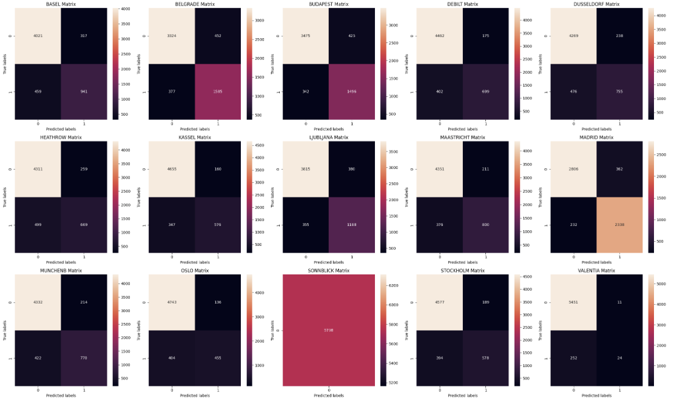

|  |  |  |  |  |  |
| --- | --- | --- | --- | --- | --- |
| Weather Station | Accurate Predictions  True Negatives/True Positives | | False Positive | False Negative | Accuracy Rate  (Overall Percentage of Correct Predictions) |
| Basel | 4021 | 941 | 317 | 459 | 86.5% |
| Belgrade | 3324 | 1585 | 452 | 377 | 85.5% |
| Budapest | 3475 | 1496 | 425 | 342 | 86.6% |
| Debilt | 4462 | 699 | 175 | 402 | 89.9% |
| Dusseldorf | 4269 | 755 | 238 | 476 | 87.5% |
| Heathrow | 4311 | 669 | 259 | 499 | 86.8% |
| Kassel | 4655 | 576 | 160 | 347 | 91.2% |
| Ljubljana | 3815 | 1188 | 380 | 355 | 87.2% |
| Maastricht | 4351 | 800 | 211 | 376 | 89.8% |
| Madrid | 2806 | 2338 | 362 | 232 | 89.6% |
| Munchenb | 4332 | 770 | 214 | 422 | 88.9% |
| Oslo | 4743 | 455 | 136 | 404 | 90.6% |
| Sonnblick | 5738 | |  |  | 100% |
| Stockholm | 4577 | 578 | 189 | 394 | 89.8% |
| Valentia | 5451 | 24 | 11 | 252 | 95.4% |
|  |  |  |  | **Average** | **89.6%** |

When the parameters are changed to 1-15, the train data set becomes less accurate with predictions compared to lower parameters (1-4). However, the test set has slightly more accuracy (about 1%) with a higher number of neighbours uses.

Parameter values:

Starting: 1-4

Trialed: 1-15

Final: 1-4

A scaled data set and the original prepared data set were used to see how it may affect the accuracy of the KNN model. The KNN weather prediction models show different accuracy levels for each of the 15 stations, with Sonnblick achieving perfect accuracy (100%) at predicting unpleasant weather with both versions of data. This suggests the model is highly accurate at predicting unpleasant weather when faced with data patterns like those of Sonnblick during training. However, this could indicate overfitting and leads to the concern of the adaptability of the model. The overall accuracy rate for the scaled data was 88.1% and the non-scaled data 88.4%. Each version of the model had larger accurate predictions for true negatives (unpleasant weather) suggesting the model may work better for this type of prediction.

**Key Takeaways:**

* **Accuracy Differences**
  + Sonnblick has 100% accuracy and Valentia 95% accuracy while other areas show lower accuracy like Belgrade or Heathrow. Comparing the numbers between false positives and false negatives, the model seems to struggle slightly more with accurate prediction of “positives” (pleasant weather). This means that the model has some disparities and that its performance varies depending on weather patterns from various geographical locations. This could therefore mean that it may not be a good fit for predicting weather patterns in certain locations.
* **Overfitting Risk**
  + The models 100% accuracy causes suspicion of overfitting. A model can be described as overfit when it appears to have learned the data “too well” and has incorporated noise and outliers during training. This means that its performance will likely be worse on new data. In this regard, the data set used in this training seems to have not properly exposed the model to a diverse range of weather conditions. It could be that our data is slightly biased with many of our data points demonstrating unpleasant weather vs pleasant weather.
* **Generalization Issue**
  + Most weather stations seem to be predicting accurately at around an 86% level without the skew from Valentia and Sonnblick. That being said, there is still a concerning amount of variability between the accuracy predictions for all stations which suggests the training data may not fully represent real-world conditions. In order for a model to predict well, and across different areas, a model should be able to generalize.
* **Improving Evaluation/Future Improvement**
  + Ideally, this model should be tested with a larger and more varied data test. Incorporating more robust data, covering the above noted discrepancies (not enough pleasant weather data), should help the model distinguish different weather types better. Ultimately, a more accurate model would likely be the outcome if the data we have was expanded on.

In conclusion, the current model demonstrates strong performance with “unpleasant weather” predictions in certain context. However, the overall effectiveness of the model is questionable and its accuracy, if applied to real-world conditions, does not appear to be ideal. In order to improve upon these issues, a more comprehensive approach that incorporates data that is robust and diverse should be used. In doing so, the model would hopefully achieve a more accurate prediction rate improving upon its capabilities to predict weather conditions in real world scenarios.